Reimbursement for Telemedicine
Medicare Part B also pays for E-visits or patient-initiated online evaluation and management conducted via a patient portal. Practitioners who may independently bill Medicare for evaluation and management visits (for instance, physicians and nurse practitioners) can bill the following codes:
- 99421: Online digital evaluation and management service, for an established patient, for up to 7 days, cumulative time during the 7 days; 5–10 minutes ($15.51)
- 99422: Online digital evaluation and management service, for an established patient, for up to 7 days cumulative time during the 7 days; 11– 20 minutes ($31.04)
- 99423: Online digital evaluation and management service, for an established patient, for up to 7 days, cumulative time during the 7 days; 21 or more minutes. ($50.16)
Clinicians who may not independently bill for evaluation and management visits (for example – physical therapists, occupational therapists, speech language pathologists, clinical psychologists) can also provide these e-visits and bill the following codes:
- G2061: Qualified non-physician healthcare professional online assessment and management, for an established patient, for up to seven days, cumulative time during the 7 days; 5–10 minutes ($12.27)
- G2062: Qualified non-physician healthcare professional online assessment and management service, for an established patient, for up to seven days, cumulative time during the 7 days; 11–20 minutes ($21.65)
- G2063: Qualified non-physician qualified healthcare professional assessment and management service, for an established patient, for up to seven days, cumulative time during the 7 days; 21 or more minutes. ($33.92)
Virtual Check-in services (established patients)
HCPCS code G2012: Brief communication technology-based service, e.g. virtual check-in, by a physician or other qualified health care professional who can report evaluation and management services, provided to an established patient, not originating from a related e/m service provided within the previous 7 days nor leading to an e/m service or procedure within the next 24 hours or soonest available appointment; 5-10 minutes of medical discussion. ($14.80)
HCPCS code G2010: Remote evaluation of recorded video and/or images submitted by an established patient (e.g., store and forward), including interpretation with follow-up with the patient within 24 business hours, not originating from a related e/m service provided within the previous 7 days nor leading to an e/m service or procedure within the next 24 hours or soonest available appointment. ($12.27)
Virtual check-ins can be conducted with a broader range of communication methods, unlike Medicare telehealth visits, which require audio and visual capabilities for real-time communication.
Nonphysicians (QHCP) who a licensed and credentialled can bill:
98966 Telephone assessment and management service provided by a qualified nonphysician health care professional to an established patient, parent, or guardian not originating from a related assessment and management service provided within the previous 7 days nor leading to an assessment and management service or procedure within the next 24 hours or soonest available appointment; 5-10 minutes of medical discussion ($14.44)
98967 … 11-20 minutes of medical discussion ($28.15)
98968 … 21-30 minutes of discussion ($41.14)
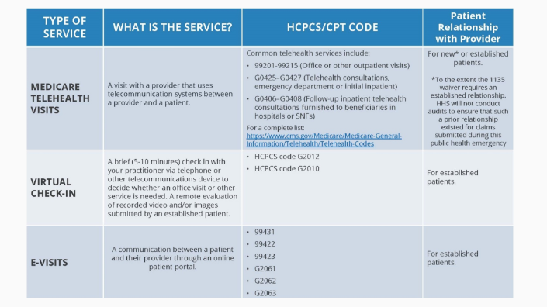
Summarize the discussion and document time spent

